**Module 7: Critical Thinking Assignment**

Brady Chin

Colorado State University Global

CSC500-1: Principles of Programming

Dr. Steven Evans

June 30th, 2024

**Module 7: Critical Thinking Assignment**

This weeks critical thinking assignment asks us to write a program that prompts the user to enter a course number then display the course room number, the instructor, and the meeting time.

**Takeaways**

I didn’t find this assignment to be too difficult as we have already done projects that have similar concepts to this one. I found the try and except blocks of code very helpful (Colorado State University Global, 2024). This is something that we’ve had to implement in previous assignments and something that we will use a lot in our programming careers.

I started to think about how this project could be implemented but on a larger scale. In a university, for example, there will be hundreds of courses with different professors, meeting times, and room numbers. Creating larger dictionaries for this would be very time consuming and there will be lots of room for error. I believe that in this example, a database would need to be created to better organize all this information.

**GitHub Repository and Pseudocode**

GitHub Repository: [LINK](https://github.com/bradychin/csu-global-projects/tree/a7e3724c0008c930d96c62babee0673ce6679c76/Principles%20of%20Programming/Critical%20Thinking%20Assignments/Critical%20Thinking%207)

Pseudocode: [LINK](https://github.com/bradychin/csu-global-projects/blob/a7e3724c0008c930d96c62babee0673ce6679c76/Principles%20of%20Programming/Critical%20Thinking%20Assignments/Critical%20Thinking%207/CT7Pseudocode.txt)

**Screenshots**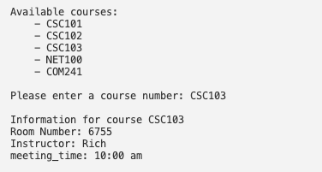

**References**

Colorado State University Global (2024, May 13th) *7.3 Handling Exceptions Using try and except.*

<https://csuglobal.instructure.com/courses/93533/pages/7-dot-3-handling-exceptions-using-try-and-except?module_item_id=4786701>